RENEWAL APPLICATION FORM FOR
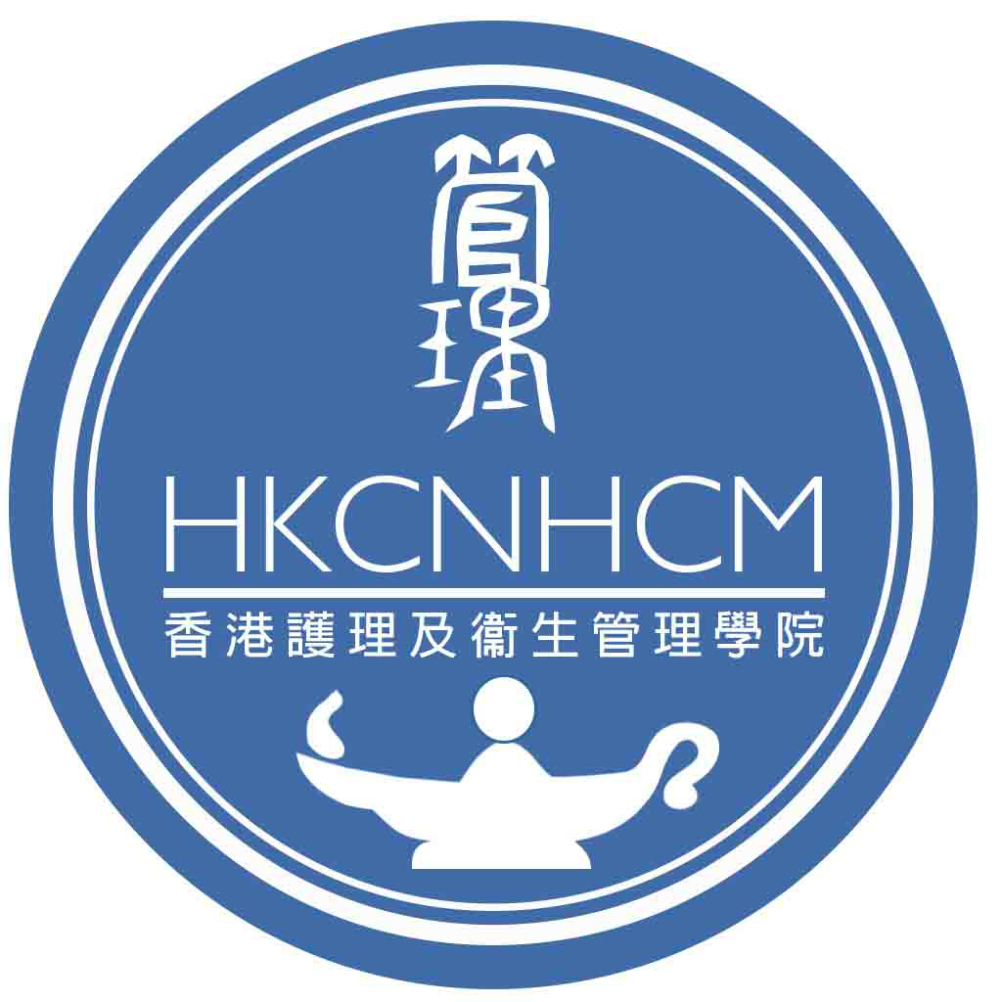
FELLOW MEMBERSHIP

I, |  |  | Fellow Diploma Number:
Fellow Member of the Hong Kong College of |  | Hong Kong College of Nursing & Health Care Management
 | am applying for renewal of Fellow Membership for the Year April 2022 to March 2023.

Please update any change since last renewal in April 2021

My personal information |  | Remarks
Present Rank
Work place
(Hospital or institution name/ward)
*Update Nursing Practicing Certificate | Registration Number : | Valid till ( )
Personal e mail address
(Not work place one)
Residential Address
Contact Telephone No.
Others: Please specify:
*With supportive documents enclosed

I hereby declare that the above information is accurate to this date and I agree to provide the above information to Hong Kong College of Nursing and Health Care Management (here below refer to the College) and the Hong Kong Academy of Nursing in support of this application. I understand that it is my responsibility to inform the College for any change of the submitted information. The College will not have to be responsible for any issues arise as a result of my failure to inform the College.

am NOT renewing Fellow Membership for the Year April 2022 to March 2023.
Please be informed that the “Fellow Membership” status would be removed if an annual subscription is not received and the individual will not be allowed to use the designated title. The individual would need to re-apply after the removal of the Fellow status. It is subject to approval from HKAN and settlement of all the accumulated unpaid fellow membership fees

I enclose herewith: (# delete as appropriate)
a crossed cheque for #HK$2,000 / HK$1,000 with cheque no. __________ of _______________ Bank to be payable to HK College of Nursing and Health Care Management Limited as the annual membership fee from 1 April 2022 to 31 March 2023.
a bank transfer receipt (reference no. _____________ ) for #HK$2,000 / HK$1,000 being debited to HK College of Nursing and Health Care Management Limited [Bank of China (Hong Kong) - Bank A/C: 012-878-0-010971-1] as the annual membership fee from 1 April 2022 to 31 March 2023.
a cash-in bank advice (reference no. _____________ ) for #HK$2,000 / HK$1,000 being debited to HK College of Nursing and Health Care Management Limited [Bank of China (Hong Kong) - Bank A/C: 012-878-0-010971-1] as the annual membership fee from 1 April 2022 to 31 March 2023.

Note: Please mail (with sufficient postage) this renewal application form and the supportive documents together with the crossed cheque (HK College of Nursing and Health Care Management Limited) / a bank transfer receipt/ a cash-in bank advice to Address: Administrative Office, Hong Kong College of Nursing & Health Care Management Limited, LG1 School of Nursing, Princess Margaret Hospital, 232 Lai King Hill Road, Lai Chi Kok, Kowloon, Hong Kong.

____________________________________ __________________________________
Signature of Applicant Date

FOR ACADEMY COLLEGE USE
Endorsed by:
 | Signature Block Letters Dr. POON Wai Kwong | Date __________
 | (President)

* Delete as appropriate

Note on Personal Data Protection:
Personal data collected in the form would be used for necessary administration and kept in complied with the requirements under the Personal Data (Privacy) Ordinance (Cap. 486).The collected personal data would not be transferred to any unrelated third parties without data subject’s prior consent.

